The Shadow Hunter:
The shadow hunter is the primary healing/defensive force on the undead squad. Yes a good avant and/or rd can really bolster your defenses but where are they when a leto and sashi are chasing your ally? This sly jamacian troll has many tricks up his sleeve.
Spells:
Healing wave
The SH heals an allied hero for x amount of mana and then it bounces y times healing less and less health each bounce. Stats:
Level 1: Bounces 2 times, heals 100 hp on initial target
Level 2: Bounces 3 times, heals 150 hp on initial target
Level 3: Bounces 3 times, heals 200 hp on initial target
Level 4: Bounces 4 times, heals 250 hp on initial target
Level 5: Bounces 4 times, heals 300 hp on initial target
*note: in current version of N, level 5 does not work *
Mana Cost: 100
Cool down: 13 Seconds
Pain ward
Places a ward the takes x hp off enemy units every second. Can be dispelled. Does constant damage no matter armor/magic resistance. Stats:
Level 1: 10 damage/sec
Level 2: 20 damage/sec
Level 3: 30 damage/sec
Level 4: 40 damage/sec
Level 5: 50 damage/sec
Mana cost: 125
Duration: 20 seconds
Cool down: 20 seconds
Etheral mine -Le sex
Places a ward down that when activated stuns them for x seconds and does y damage. Wards, once laid, then go invisible. They have to say invisible for some amount of time before they can stun anyone. Can be dispelled(you can even devour them). Stats:
Level 1: 4 second stun, 80 damage
Level 2: 5 second stun, 135 damage
Level 3: 6 second stun, 190 damage
Level 4: 7 second stun, 245 damage
Level 5: 8 second stun, 300 damage
NOTE: half duration stun on heroes.
Mana cost: 115
Duration: I'm guessing around 100 seconds or so.
Cool down: 9 seconds
Big Bad Voodoo
Cause units in an aoe to go invulnerable whilst the shadow hunter is using the spell. It's a channeling and the effect wears off once he stops channeling it.
The SH himself does not go invulnerable. Stats:
Level 1: 180 second cool down
Level 2: 150 second cool down
Level 3: 120 second cool down
Mana cost: 200
Duration: 30 seconds
That is a basic description of the shadow hunter and his moves, now let's get onto game play and other such things.
Game play
Move set:
1: Pain Ward (1)
2: Etheral Mine (1)
3: Pain Ward (2)
4: Healing Wave (1)
5: Paint Ward (3)
6: Healing Wave (2)
7: Healing Wave (3)
8: Healing Wave (4)
9: Etheral Mine (2)
10: Big Bad Voodoo (1)
11: Big Bad Voodoo (2)
12: Etheral Mine (3)
13: Etheral Mine (4)
14: Etheral Mine (5)
15: Pain Ward (4)
16: Big Bad Voodoo (3)
17: Pain Ward (5)
18: Healing Wave (5)
Item Set
Item sets can vary. There is no whole item set that you must have, but there are variations depending on your situation. If you tend to be staying around middle a lot then i find putting 1 or two sobi's in there is good, but if you're playing at the expo's pendants all the way. But if you want quick towers only get one pendant, and some mana pots, and then pool the rest(of course buying boots of speed). So i usually go something like this:
Boots of Speed - Must
Mana Pendant - Must
AME - Must
After that, it depends on what type of SH you play. Personally, i spam all my spells all the time so i get another 3 pendants. If you're more layed back get some sobi's.
Early game i always get 3 sobi's first before i get a mana pot. My usual item build looks like this:
sobi1
mana pot
sobi2
boots of speed
ams
sobi3
sobi1 -> pendant
sobi2 -> pendant
sobi3 -> pendant
mana pot -> pendant
Sobi's are better off early since either way you don't have enough mana to spam spells or gold to buy the mana. After that, start trading in your sobi's for pendants and then mana pot last. Always have an ams and keep replacing it.
Never use the mana pot unless it is really needed. Don't just go spamming your mana thinking you have a mana pot in reserve, it doesn't work like that. Only spam your mana to get a hero kill or keep and ally alive. Then after that, if you have a pendant, drop the pendant and use the pot, if not just use it. When being chased by ninjas and such and you are running low on mana you cannot drop the pendant so just heal anyway. Do anything to stay alive. Remember when dropping your pendant and healing to be far away from the battle, i mean far away. And scope out the area before hand. Once, being reckless, I've had my pendant stolen by a damn voiding sashi.
Skills: How to use them
Now that you are familiar with what each skill does, and what skill build to go i will explain how to use each individual skill to it's maximum affect.
Healing Wave:
I find this to be the far greatest healing spell in the game. It is not as powerful as it once was but still heals quite a lot. With healing there is one key rule: ALT KEY IS YOUR FRIEND. If you don't know what the alt key does then I'll tell you(nub). When it is being held down it displays the current hp of any unit that you can see. I always have the alt key held down, i find myself pinging for no reason sometimes as well. You always need to know the current hp of your allies and every moment in time. There is a good deal of experience requires for choosing when to heal. The experienced required is knowing how much hp your allied hero has if his bar is down so much(guesstimating). SH's heals don't come cheap, especially when you have other spells to spam, so never try to waste a heal. Of course, if someone is getting ff'd, just heal them straight away. Remember to have your priorities right. If you see them ff'ing jimmy on 80% health, and then dotm on 50% with sashi after him heal dotm. Heal the weaker ones first and let the tanks well tank. Do not endanger your life running through heroes to heal someone unless you know you can get out(ams with mines all over the place). It is not worth trying to save him at the risk of losing SH. Remember that it only has 4 bounces so you cannot heal all 6 heroes. Always target healing wave on the hero that needs it the most and let the bouncing do the rest. Remember that bouncing automatically targets heroes first, so in the situation before with endangering yourself, you can try healing someone closer and then the bounce reaching the hero in danger. Just need to rely on the luck of the bounce.
Pain Ward:
Not quite as sexy as it used to be. It's still as effective as it used to be but etheral is just so much better. With the skill builds suggested before i don't get PW till late and i don't even use it till level 3, and if you're using that skill build neither should you. Just place it in the place where it could do the most damage. Heroes now days forget about PW. You don't use it all game and save it right for the end that they don't even bother to kill it. Still good for pushing spawns, but use it in a more hero offensive way. If you see someone stun a hero on their team immediately place a ward then a mine. It is also good to block choke points by placing them right next to each other. I remember blocking a jean at top once she was stunned by placing both wards behind her and then the ghouls surrounding her. It'll happen, but only in rare occasions. You're better off placing it in the middle of heroes or when ff'ing a hero.
Etheral Mine:
Etheral mines are le sex of the SH. These can single handedly stop one of your allied heroes from dieing, hold off a push enough to heal, used offensively to stop ambushes, even for scouting. What can't these little shits do? Early game you can try offensive mining. This involved predicting where the hero will come from and then blocking escape routes with mines. If you see heroes come down the allied ramp in top mid then make sure you have one mine at the ramp to top. They think they have gotten away and then bang. Or just place them there to scout, no ambushes from up there. It is hard ambushing someone with mines since units can trigger the stun and you have to guess which way they go, but it's very effective if it can be executed. Remember to always mine choke points, thus eliminating a hero going around them. This means when at top: Mine the bottom left exit of the expo. When at bottom: Mine left exit, and two at top exit. These places are crucial for mining. Any hero that thinks they can visit your base and flee on low hp will think again. Another nice place to mine is the bottom entry to the allied top expo(between the cliff and the trees) This means that when they try to rush you from there you will have a heads up. That's offensive mining out of the way, not onto defensive mining. This is just placing mines in your lane until you reach the spawns. Every cool down just pop one down, making a line from where you started till you reach spawns. Never place a mine over spawns, make sure no spawns are in the aoe. When at top or bottom make sure there is a line from the expo to where you are now. This is for when an allied hero tries to chase you down they get bombarded by mines, and then when they counter push it gives you all enough time to heal. Spam them every cool down and never place them in another's AOE. I have seen people place them next to each other for the AOE damage but i highly recommend you don't do this. Instead just spam them every cool down from your base to theirs. Mines are also good for keeping a chain stun going. Once you see an allied hero stun place one some distance in the way they are going to be running. And to break channeling spells, no need to whack them right on top of the hero, just make sure they are in the AOE.
Screen Shots:
Defensive mining:
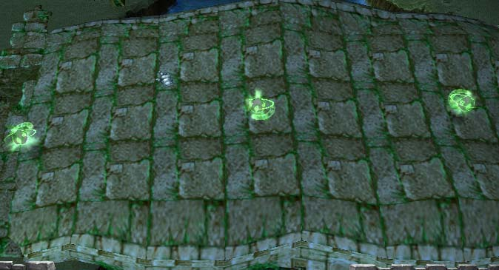
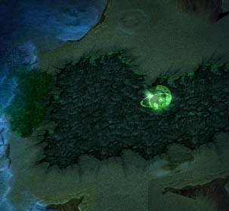
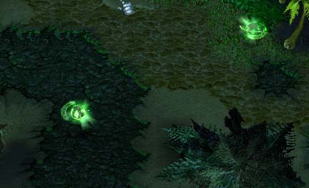
Scouting/Offense:
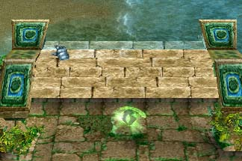
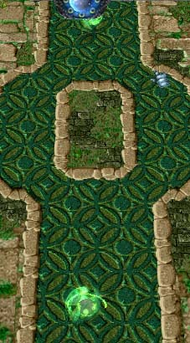
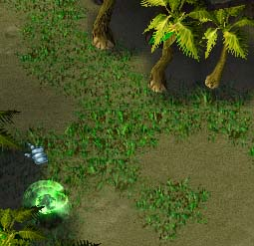
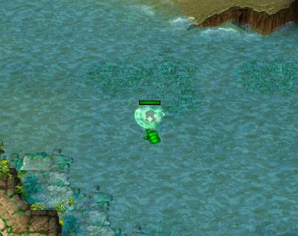
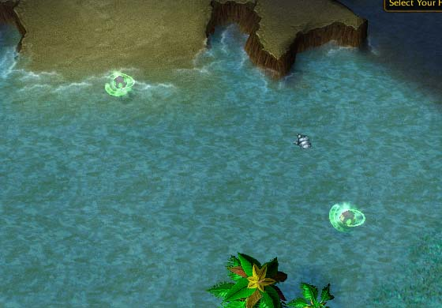
Pure Offense:
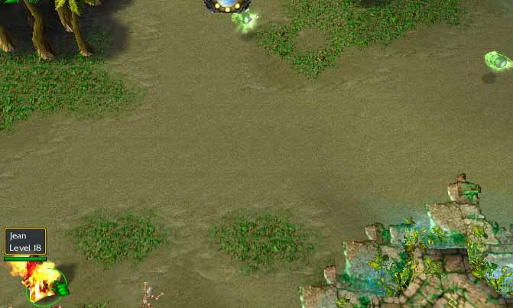
Big Bad Voodoo:
Big bad voodoo is my personal fav. and therefore should also be called le sex. This more just smells of sex it's that damn sexy. If you think this is just for sieging you are dead wrong, i maybe use it once or twice for sieging. It's the BBV save that makes you look like a pro in the end. How to BBV save might you ask, simple. When going into a battle always be ready to voodoo, i mean always. If you see leto and sashi lurking the the bushes then suspect them to try to wind + tgp someone. Once that happened hot key voodoo, save them, once tgp runs out you run as well. Never ever voodoo longer than you need. Also be careful of flare, is it packs a wallop. If all your heroes/units are in a bunch and it's been a while since she let one rip(ha ha) be ready to save their asses. Watch jean as well, as her animation gives away her flare. Once the heroes are out of the aoe run, even though flare may still be running do not risk dieing, you are too valuable. If they run back into the flare then they too stupid and deserve to die. If you see a hero running on low health being chased by a number of heroes and heal isn't ready, get ready to bbv save his ass. Wait till he gets in range and bbv, wait till he has almost reached you, whack on the ams and run. You need to hit the ams as soon as fucken possible. You are so close to the battle they can spell you, and sashi is just niggling to stun you. Sometimes i find a 1 second bbv enough to save someone. Run in, bbv quick and out. They are trying to ff him and once he goes invul the AI tells them to go attack the nearest vul unit. This one second can be enough to save your hero, and make yourself look like a pro. If you are using it while sieging then always, i repeat always, hit ams before hand. Don't want malf(nub) or sashi stunning your ass, jean is also a threat. The only thing to be careful of is leto and inquis. If you see inquis running at you run back. You don't need to be right in the middle of the battle to bbv sage, i usually find doing it far away can be as effective. Why? Sometimes at night time, doing it further away means they can't see you at all. This means you can flood the choke point with invul units and they still can't see you. Or doing it even further away and making sure the siege wagons don't get destroyed. Only do this if there are minimal heroes defending the base(1/2). And one last thing bbv is useful for, bbv repairing. If you want your workers to repair a tower without being hassled be heroes trying to kill them, bbv in base and let them repair without any hassles.
Nice Spot:(i know i don't have an ams but it was single player and fuck running to base to buy one)
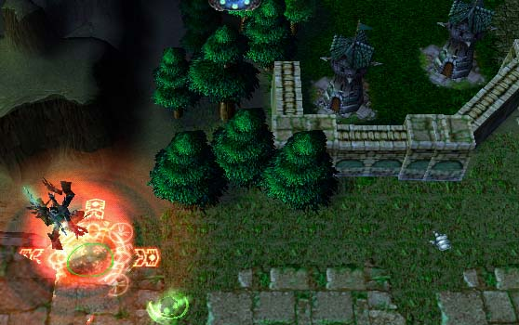
Early game
Early game can vary depending on what lane you get. I personally like going bottom right off the bat. You get there first and win the first push giving you 2 free levels before anyone. But you can go mid as well, depending on how early your team mates need your healing support.
Going Bottom
If you have chose the route of going bottom then these are the things you must follow. Pick SH as fast as you can and then straight away make him go bottom.
Once there do what you must to win the first wave with at least 2 ghouls. This pretty much guarantee's you have the next several pushes won. Try only spam mines when you are pushing a group of spawns and not several. Save your mana just in case two of your spawn waves get knocked out by their towers and they have a big push coming. Big pushing = lots of XP bags. Generally for bottom it's best not to leave until level 8/9, getting 3 levels of etheral by 5, then maxing healing wave with bbv anywhere in there, but getting it before you leave. Be sure to have an AMS so you don't get served by slow.
If a jean or maiden is at bottom it's best just to spam mines(not spam spam, dash cunning spamming) so she does not get to a high level. A higher level jean will always win the push against you. If you see jean under leveling you get out of there, and make sure bottom is guarded by either a hero or workers ready to repair after flare.
If a melee hero(leto) is at bottom then they have no chance. Every chance you get melee them, every. Only stop if they are so far back you can't get exp or are next to towers. Just keep at it, keep them away from the exp. This could also work with ranged but it's a little harder since it's easier for them to hit you back. If you see the melee unit attacking you then it's all good, job done. They need to melee the target to win pushes, while you use spells to win pushes.
You do not need any items, unless you really want to. I just wait till I've gained enough XP then buy pendant and boots. At bottom it is easy to save for pendant and you should be.
Going Mid
Going mid could be better or worse, depends if they saved their hard pushers for here and if you're against the gay agility duo. When i play sashi and have a friend leto in the same lane we run straight for the SH. Fuck the spawns, straight for the SH, make him squirm around. If you ever get caught in this situation there are some things you can do:
Run around ALOT, never ever stop - You should always be doing this but just saying
AMS - Don't buy two mana pots, ams a lot more useful.
Get a tank. If you haven't noticed, from the start you can buy a tank with ease if everyone pools.
Stay really far back and only come in to etheral.
Tank is the easiest but costs the most money. In mid just level like you normally would, never spend all you mana, make sure you have at least 150 mana after level 5. In mid go for the two levels of etheral then maxing healing wave build. It is also a really good idea to have a necro ferrying you items. In mid i find I'm using a lot more mana and further from the fountain so my necro is ferrying a lot of mana pots. Save up for the mana pendant and then remember to drop pendants before you use pots. You should always have one pot and one AMS in your inventory for the entire time here.
Around level 6 go with the group. Do not ever solo, i repeat, never ever solo. If the allies see you soling they will jump you as soon as they can, and you will die. I know it's a bitch, trying to power level or something, but you have to do with the mob.
Mid game
Mid game is a bit of a gamble. If you are at an expo it's a choice wether to stay at that expo and continue leveling normally, or if not going middle to help with the most exciting part of the game, hero abushing. I personally rather stay where i am, as leaving at expo could result in them rushing it or just the good not out waying the bad if you don't kill many heroes and in the process dieing. Remember all the time to have a necro ferrying you items whenever you need them. I find getting items in this order: Mana pot, ams, boots of speed, sobi, pendant. Get a mana pot and ams before anything, boots after, as many sobi's as needed after that and pendant last, with of course replenishing consumables whenever you use them.
If you are in the middle during mid game you will be doing alot more offensive mining and definately doing bbv saves. Remember that you do not have all your items yet so your mana pool and regen rate aren't sufficient enough to be spamming mines and heal. Places mines only in offensive places where you think they will ambush you from or they will run after ambushed and lastly behind you so you have some chance of getting away at low health. Also, if there is a big scale battle with the majority of heroes place one right in the middle and then save everything for heal untill you hit 200 mana. Once you hit 200 mana you have a choice to make, use this to heal or save just incase you need bbv. More often than not i save it for bbv unless i am willing to sacrifice my pot. In middle you will never know when you need to pull off a save so always keep your mana high, never run around with less than 250 mana, even with a pot.
If you decide to rush a mid base make sure you place mines in a choke point, or several. Do not stay at the back, stay more in the middle. Try guess where they will come from after that and go the opposite way. You do not ever want to be anywhere near the front of the battle. These are the situations where you must be the most alert as they will be grouping to counter your seige, be careful.
If you decide to seige bottom expo this is where you can have some fun . What i do is place mines at the top choke point in a line to the bridge and then up until the expo. This gives you ALOT of warning and will help you dramatically if they try get you from behind. I have a video of me recently doing this to a cow which didn't know what was happening. He hit 5 mines in a row and then proceded to die. I will be uploading this soon for yours and my enjoyment.
At top expo make sure you place a mine in the choke point and several behind you for running away, one near the seige won't hurt as well. If you bbv make sure ams is on and a mine is nearby as leto might want to be tricky and tgp you.
Advanced tactics
There are certain differences between a good SH and a very good SH. None of these can be achieved by reading this guide. I can tell you what a good SH does but then you have to put in the man hours to practice this. It's not only about practicing SH, it's about knowing every hero. By playing every hero and being competent you will know what to expect from them when playing against them or with them. Simple as this: play more TOB. Some things that a super nerd tob player like myself knows are:
Cool downs of spells
Damage of spells
Standard skill builds
Your opposition
If you know all these you SH's effectiveness will increase dramatically. Let's go into a little bit more detail.
Cool down of Spells
This is one of the more important things. I am not saying memorize the cool down of every spell, I'm just saying know enough about the game to make a fairly accurate estimation of the cool down. This is so when you are being chased heroes that used their nuke on you when ambushing, you know how long you have before they can use it again. This is especially important for:
Wind
Prana Bindu
TGP
Moove
Damage of spells/Standard skill builds/Your opposition
These three things here are all related. You cannot know how much damage a spell will do accurately without knowing the standard skill build for that hero and your opposition. You may know the standard build and your opposition may be a friend who you know differs slightly. You need to know all of these things. Most of the time you can estimate by taking the heroes level and doing mod 2 onto it and that'll give the level of the primary skill. You can guesstimate the rest from there. This is particularly important for:
Phoenix Wake
Flare
Crimson Wake
Pluck Yew
Acciphers
Wind
Inquis ult(forgot the name)
With wind it's more the stun duration than damage.
Knowing the standard skill build is also good by itself. When everyone is 18 there is no room for leniency as everyone has all their spells maxed. But early levels you can be a little lenient if you a certain a hero doesn't have a particular spell. Like for example a leto saving ww for last. But this is were knowing your opposition will help as they might do something different. Be always aware what skill every hero has.
SH Mad School Dodging Tech 101
Dodging is one of the key things a good SH does. It is achieved by knowing the above 4 things and also just being random. You have to think what the opposition is going to think you are going to do. At times when on low hp this is especially critical but easier to do if you keep your calm. Any FPS like quake will help you a lot with this. This is because when playing these sorts of games you cannot be random or you will die. You have to try dodge their shots without having any coherency to your motions or else they will know where you are going to go. The key is random.
This is when knowing cool downs is especially important, most importantly wind and bindu as they are the two moves that will catch you off guard when running away. Be aware of when they can be used again you think they are going to use it run in random directions like a mad man. I am saying premeditate as we are not playing on lan and it is pretty much impossible to dodge anything with Internet ping just by seeing them use the move. I have a couple videos of when i played a good SH in my opinion and will be uploaded to demonstrate this.
If you are not confident in this then just run around in small circles. It is simple and the results may not be the best but they are good enough. Be sure to place an etheral mine in the middle of the circle as if it stuns them it will give you some time to make a run for it.
It's all well and good trying to predict their spells and dodge them but you have to think, are they going to do the same thing over and over again? No. You opposition will adapt to the way you play thus you have to adapt again. An SH is always one step ahead. How do you do this you might add? Well let me get some thing sorted out first.
1) Noob running tactic
Low hp, run straight for well. This is what any new SH would do, run in a straight line for the fountain. Really bad no no. You can be predicted so easily and will pretty much die every time.
2) Pro running tactic
You now want to counter their offense by running a random path to the fountain and predicting their dodges. This will work up until they realize what's happening. What do you think they do now? They just melee you to death. Because you are running a fairly random path this path is a lot longer than the straight path, so they use advanced BR guide tactics, right click and wait. They wait until they KNOW where you are going to go and then nuke.
3) Even more pro tactic
Run in a straight line so they melee you only once and then can't catch up.
Do you see any similarities between 1 and 3 here? Essentially they are the same. But this time you actually have to dodge the moves rather than running around like a chicken with it's head cut off. You have to anticipate their next move and when you think they are going to do it, run around it.
Being Really Stupid
This i find only works some of the time. I remember when i played Pokemon on the Internet a while back. One of the best things i had going for me was i couldn't be predicted all the time. Just say i had a ground Pokemon in against your water. Usually i would anticipated a water move, so switching to one of my water Pokemon would be a good choice. But they think about this and their water Pokemon doesn't use a water move but an electric move. But i would just leave my ground Pokemon in thus taking no damage, then switch. Essentially this is the noob, pro and then even more pro tactic i discussed earlier. Being really stupid can sometimes work in your favor. I don't mean pure stupidity but something they wouldn't predict. Like running back into the middle of battle when low on health. This is all related with randomness. If they can't predict what you are going to do it is harder for them to try to kill you.
One of the best places i find this works is when running from enemies right next to one of your mid expo's. Every opposition player things you will run to the expo for safety, i mean everyone. Right before they use their nukes do a 180 about face and run to the other mid expo. Countless sashi's have tried to stun me and just found 4 towers doing this, it's quite funny. And now with bindu having 5 second cool down it is a lot more easier to dodge the fucker.

